PacMan with Genetic Algorithm (GA)



# **Submitted To:**

Sir Kashif Zafar

# **Submitted By:**

Adil Sarwar (L11-4405)   
Zain Malik (L11-4622)

Hunain Mehmood (L11-4217)

|  |
| --- |
| Transmittal Letter  May 8 ,2014  Kashif Zafar  Professor  FAST-NU  Lahore  Dear Sir:  We are pleased to present our final report*, "PacMan – With Genetic Algorithm"*. This report adds detail to the findings and recommendations in our initial report on our term project, and strengthens our previous features of the game and adds the description regarding the new features added to the project i.e Unique Maze generation using genetic algorithm.  We look forward a great response from you regarding this project based on the features provided in this project.  Adil Sarwar  Zain Malik  Hunain Mehmood |

Contents

Introduction 4

Game Entities 5

Maze – Game Board 5

Players 5

Theme of the Game 6

Game Features 7

A chance to play with computer 7

A new Maze Layout every time 7

Map editor 8

‘AI’, the power: 8

Future enhancements and recommendations 8

Conclusions 8

List of Illustrations

**Menu….……………………………………………………….…………………………………………………….5**

**Basic Map..………………………………………………….…………………………………………………….6**

**Map with Ghosts……..…………………….………………………………………………………………….7**

**Game Play ………………….……………………………….…………………………………………………….8**

**Map Editor ………………………………………………….…………………………………………………….9**

Executive Summary

This report intends to highlight the importance of ever growing phenomena ‘Artificial intelligence’ and its impacts in the area of computer games. Real games can entertain users and that’s only possible when automated system make smart decisions …

Keeping the user requirements in mind we have improved the already implemented Pacman game. We’ve introduced Artificial Intelligence in it to make it more interesting. The game will have a large variety of maps which are generated by Genetic Algorithm dynamically each time user starts the game. A* path finding has been implemented to allow ghosts to follow the Pacman wherever it is so as to increase the difficulty level

Future improvements will be done to the game so as to make it learnable and allow the system to decide the difficulty for the user according to the user stats and history.

Introduction

Trending with the modern era, automated system including games have become much sophisticated and intelligent. With an ever growing increase in technology, devices have been made powerful in terms of making decisions depending upon certain conditions and successfully responding to the event. Whether humans are typing a simple email on a hand held device or making a purchase over the internet, automated systems with the help programmed services are ready to provide auto word completion suggestions and products related to what user is purchasing right now respectively.

Computer games are a source of entertainment to humans and as real a game appears to be, more exciting it is. And yes, computer games can’t just appear to be real, they can really act intelligent and make choices as humans do in various circumstances. This report has a motivation to describe a computer game where system is making smart moves just as we do and provide a little of introduction as to how system can be automated to behave smart.

**PacMan** is one such famous, remarkable game and is the subject matter of this report. The basics of the game remain same but the science and engineering knowledge of ‘artificial intelligence’ mostly known as AI when applied to the area of computer games has changed things drastically. With the advent of AI, games and almost all the software systems being developed are able to make controlling decisions.

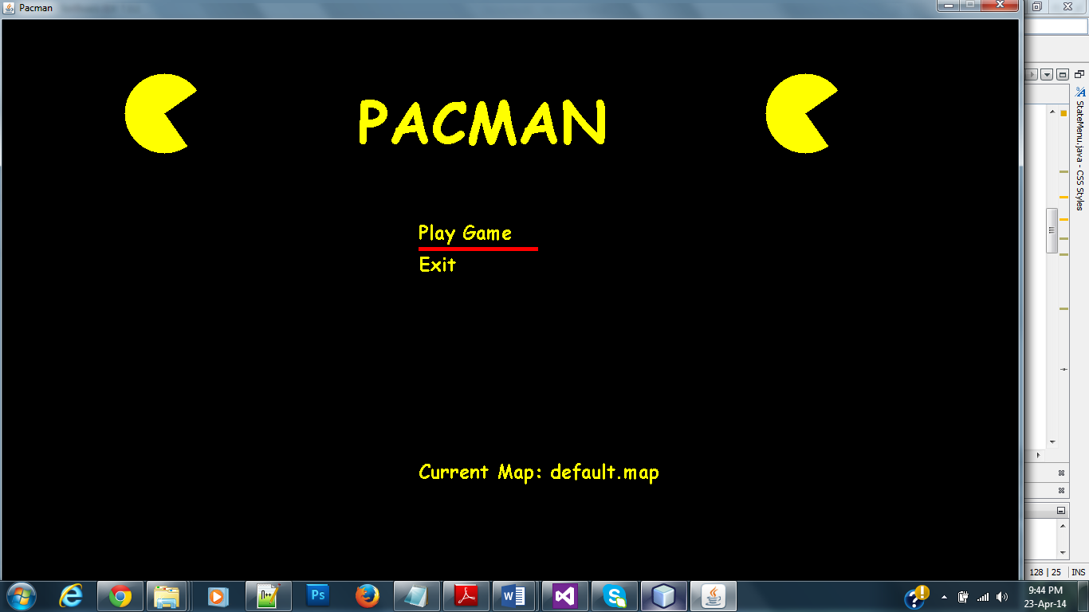

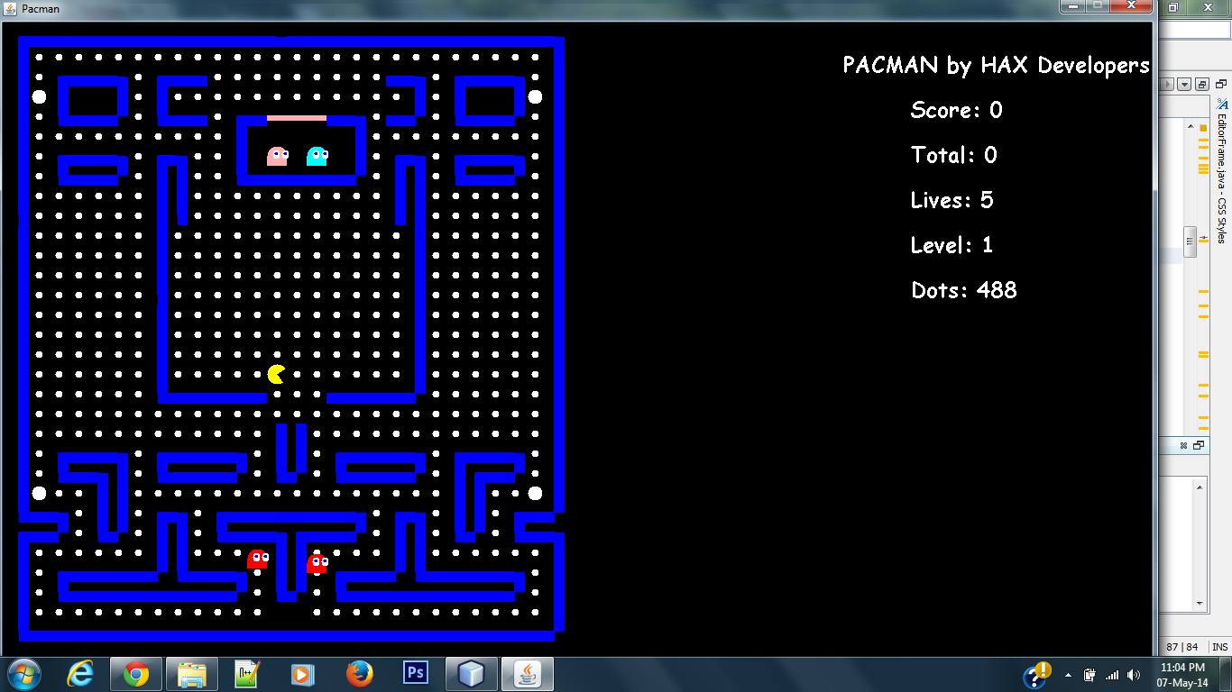

# Game Entities:

## **Maze – Game Board**

1. Top left edged wall
2. Top right edged wall
3. Bottom Left edged wall
4. Bottom right edged wall
5. Vertical wall
6. Horizontal wall
7. Eatable balls – with each is a score of 10
8. Ghost Barrier
9. Bonus Ball & the fear factor
10. Score Board
11. Lives left

# **Players**

1. User – PacMan
2. 4 ghosts, namely

* INKY
* PINKY
* BLINKY
* CLYDE

Each with different speed and dangerous in terms of their probability to catch the user – pacman.

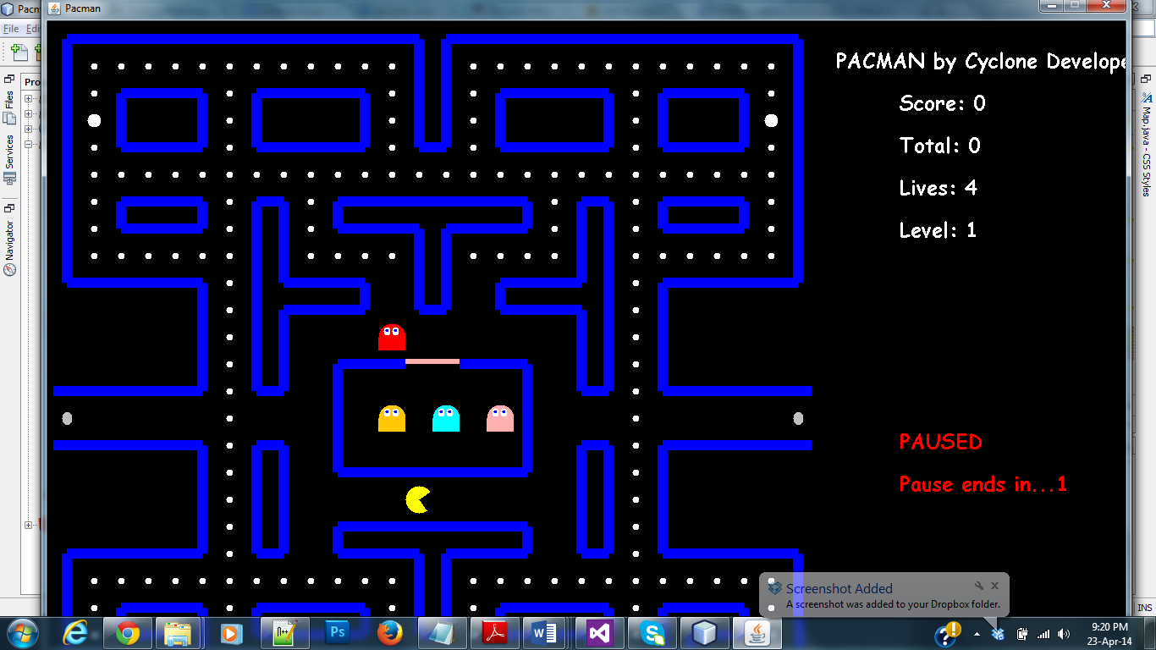

# **Theme of the Game**

PacMan is fundamentally a Predator – Prey simulation game. With game entities mentioned above and screen shots listed, it is fairly easy to understand how it goes. Human user has a control to move the Yellow PacMan up, down, left and right. PacMan has to save itself from the enemies known as ghosts and while traversing across the maze, eat all the balls. Each ball gives user a score of 10. The block where ghosts reside initially is termed as Ghost barrier. Yellow PacMan has to start a certain fixed starting point on the maze and eat the balls around. The red ghost comes out of the ghost barrier first and speedily chases the PacMan. The rest of ghosts come out of the barrier with time and move around in the maze.

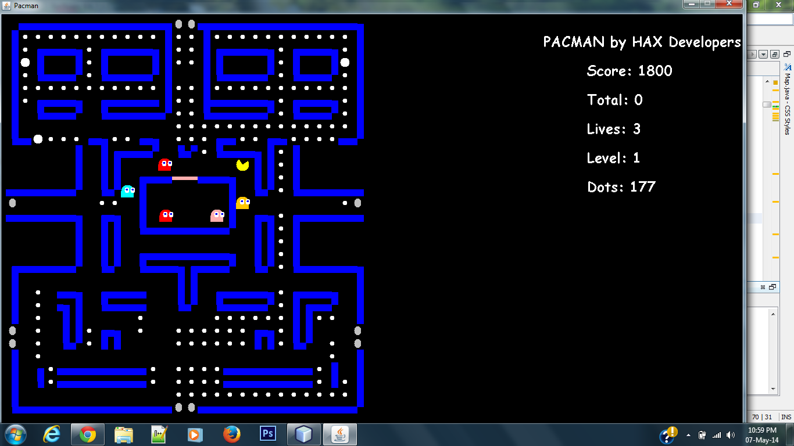

There is a bonus Ball somewhere on the Maze as well which gives user a score of 60 points on the score-board and sets on an exciting feature of the game. Once the user has eaten the bonus ball for some n seconds, ghosts are turned Grey. Being grey is a Fear state where User PacMan can eat the ghosts along with the balls. In this state, rather than moving closer and chasing the PacMan, enemy ghosts run to save their lives by moving away from the user.

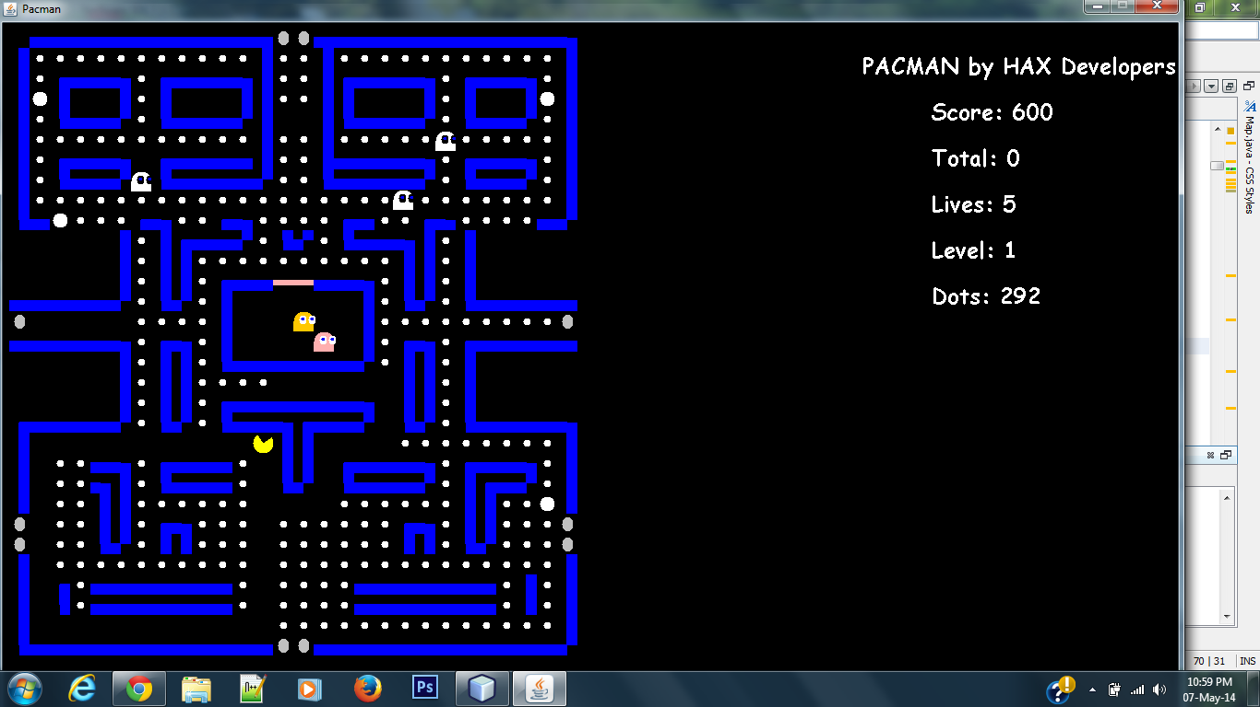

A life is decremented when a ghost enemy eats the PacMan. On the other hand Human user wins if he/she is able to trick the ghosts and eat all the balls spread across the Maze. With this brief introduction to the theme of PacMan game, further text gives an idea of how the System makes a suitable choice.

# **Game Features**

## A chance to play with computer

Let’s you play with Computer. And yes, Computer is intelligent to make the Ghosts follow PacMan in best possible ways. Ghosts acts as system agents and they move on the shortest path to user agent. This is made possible with artificial intelligence knowledge – A* algorithm.

## A new Maze Layout every time

With the help of Genetics algorithm, each time a user comes to play, a new maze layout is chosen. A careful fitness function is executed to provide a new layout with adequate aspects of game. This makes playing the game extra-ordinarily thrilling.

## **Map editor**

This lets the user draw Maze Layout as complex or easy he/she wants.

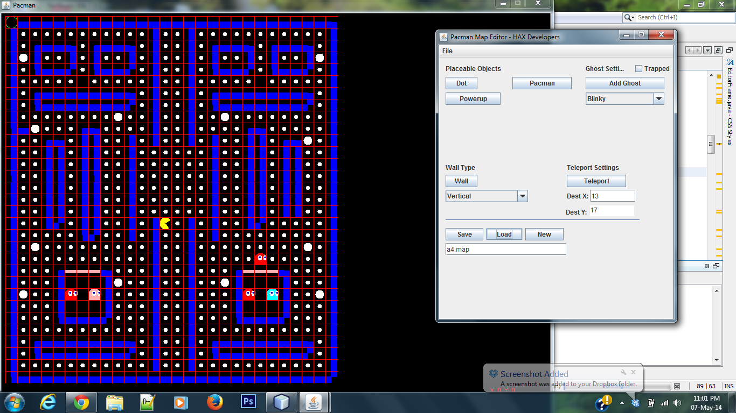

# ‘AI’, the power:

* Genetic Algorithm – This algorithm has been used to generate a unique Maze every time the game starts. This helps keeping the game interesting.
* A* algorithm – Had ghosts been running here and there across the Maze, the challenge to human PacMan won’t be much real. With A* algorithm, system is made wise enough to find the shortest path to the target and make moves accordingly at any time.

# Future enhancements and recommendations

* Local Network game
* Online game – let people play it over the web and share the high scores
* Saving User Profiles – keep history against each user
* Multi Player game – let more than one human user play it
* Put Difficulty levels and let the system decide the difficulty level of user

# Conclusions

Applying artificial intelligence to games such as PacMan provide human users a chance to play with computer tactfully because computer knows the best move to make in any situation. Agents representing computer system are made intelligent with an amount of probability. Scenarios where single player interacting with computer system making random choices isn’t much fascinating and sounds bore for many people. This report discussed an instance where application of artificial intelligence brought smart results for humans. With each day passing more and more systems are being made powerful with AI to help humans in real life activities.

References

* [http://en.wikipedia.org/wiki/A*_search_algorithm](http://en.wikipedia.org/wiki/A*_search_algorithm)
* <http://theory.stanford.edu/~amitp/GameProgramming/AStarComparison.html>
* <https://code.google.com/p/jianwikis/wiki/AStarAlgorithmForPathPlanning>
* <http://www.ro.feri.uni-mb.si/predmeti/int_reg/Predavanja/Eng/3.Genetic%20algorithm/_04.html>
* <http://www.civil.iitb.ac.in/tvm/2701_dga/2701-ga-notes/gadoc/gadoc.html>